 **Rosanna Cubs**

**– Swimming night**

**Northcote Aquatic Centre**

**Tuesday 25th March, 6:45pm-8:30pm**

This week, we’ll be going swimming (and some sliding) at Northcote Pool. This will be a fun night rather than a badge night – Cubs will have a swimming night later in the year for Swimming Badges.

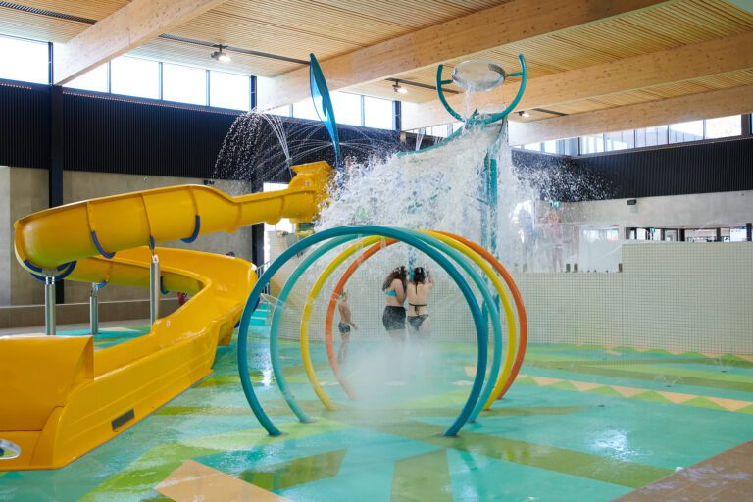

* **Time**: 6:45-8:30m – ***Note different time  
   to normal Cubs,*** *so we can get the*

*money etc. sorted out and in the*

*pool by 7!* ***Please be on time****.*

* **Cost**:
  + Child Swim $6.20
  + Adults Swim $8
  + Entry only (not swimmng) $3

***PLEASE BRING CORRECT MONEY AMOUNT***

* ***NOTE that we need to have 1 adult per 4 Children attending. Also, those not yet invested (i.e. they have a white scarf) and siblings who are not Cubs, MUST be supervised by their parent.***
* **Location**: *MEET IN THE FOYER at Northcote Aquatic Centre* –

180 Victoria Rd Northcote <https://maps.app.goo.gl/Zoo2ENpJkfaMVW3k6>

* **Bring**: Togs, Towel, **EXACT** money for your entry, & warm clothes to go home in, plus swim goggles, snacks/drink bottle if you want them.

**Don’t miss out** – see you there!

Regards

The Leaders

Rosanna Cub Scouts

See Rosanna Cubs at <http://www.rosannacubs.org>